Mailings

Mailing List

Once you contact the office, you can view a mailing list for your classmates to review. Due to privacy, this list may not leave Bishop DuBourg. The only mailing that DB will be responsible for is a Save the Date Postcard which will be mailed at the expense of Bishop DuBourg.

***When setting a date to mail the Save the Date postcards, please notify the Advancement/Alumni Office at least one week prior to the date needed. This gives the office time to gather all the information and get postcards printed for your mailing.

***Bishop DuBourg will provide DB envelopes that are pre-addressed and include a note on the outside of the envelope that states “DB Class Reunion” for your second mailing – the invitation. Bishop DuBourg High School does not provide postage for all mailings and does not have the staff to stuff mailings.

1st Mailing

For reunions it is a good idea to send out the first mailer a few months before the reunion. This mailer could simply be a save the date postcard with the reunion date on it and the rest of the information could be TBA (to be announced). The first mailer can create interest from your classmates, elicit suggestions, create ideas, and give names of other classmates who may wish to help. Bishop DuBourg will provide each reunion committee with one Save the Date Postcard mailing for their class. This first mailing will come from the school and be paid for by Bishop DuBourg. You will choose the contact information for the mailing. This mailing will also help update your class list. All returned mail will come back to DB and if there are forwarding addresses available, the post office will provide them to DB. DB will then update your class list.

2nd Mailing

The second mailer should have more information such as where, when, time, who’s invited, and what the reunion will include. With this mailing you could ask for updated address information as well as ask your classmates to help you locate lost people. You could also include in this mailer a questionnaire or survey. This questionnaire or survey is a fun way to gather information on your classmates. The answers could also be used to create a memory book for the reunion.

3rd Mailing

The third mailer can be a last minute reminder and catch any classmates who are waiting until the last day to RSVP.

You are not required to do three mailings. The amount of mailings for your reunion is up to your committee. Some groups do three mailings. Others do one or two mailings and then do an email follow up. Keep in mind when doing an e-blast that the success of an e-blast is determined by how many email addresses you have for your classmates.

Taking RSVPs

Before sending out any mailers, the committee should decide who will be taking RSVPs. It is recommended that you choose one person. RSVPs may be mailed back to committee members or accepted over the phone. Do not have people RSVP to the school.

Questionnaire

As stated earlier, you can include surveys and questionnaires in any of the mailings. Some reunions have used these to create memory books for classmates, or simply shared stories from the surveys at the reunion. Please keep in mind that if you plan to use the information to create a memory book, someone will have to step up and put together the book. And the committee will have to figure out how to arrange the printing of the book.

Other groups have used the questionnaire to read off information about people that could not attend the reunion. How you want to use this information is up to you.

Evites

Many classes use Evites. Evites is a website that allows you to send out email invitations to your class and track RSVPs and post reunion announcements. The website is www.evite.com. Some classes are also starting websites to post reunion information, pictures, and keep in contact.

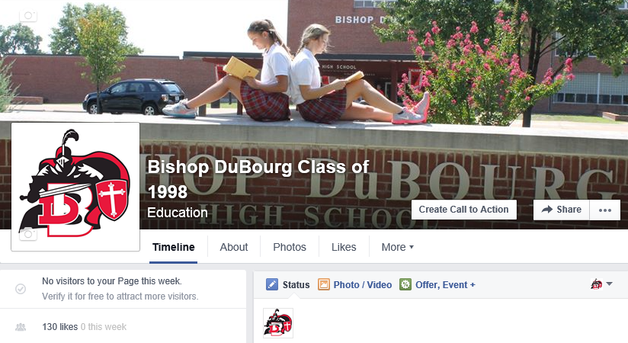
Facebook

Many classes are setting up class Facebook
accounts to help stay in contact with fellow
classmates, find lost classmates, and keep
people up to date on the reunion. Facebook
helps build excitement for the upcoming
reunion. It also allows classmates to make
suggestions and give ideas to the committee.

Website

Other classes have set up their own class website, using them to collect RSVPs and other information. If you want to set up a website one option is www.myevent.com. You can do some stuff for free with this website or get more creative and use a payment plan.

For samples of mailings, please see attachments.

Mailing Worksheet

Mailing #1

Type: DB Save the Date Card Date:

Mailing #2

Type: Date:

Mailing #3

Type: Date:

Main Contact (for RSVPs)

Name:

Name:

Name:

Ideas for Questionnaire:

Reunion Extras

There are a lot of moving parts at any event and a reunion is no different. A few things to think about while planning your event:

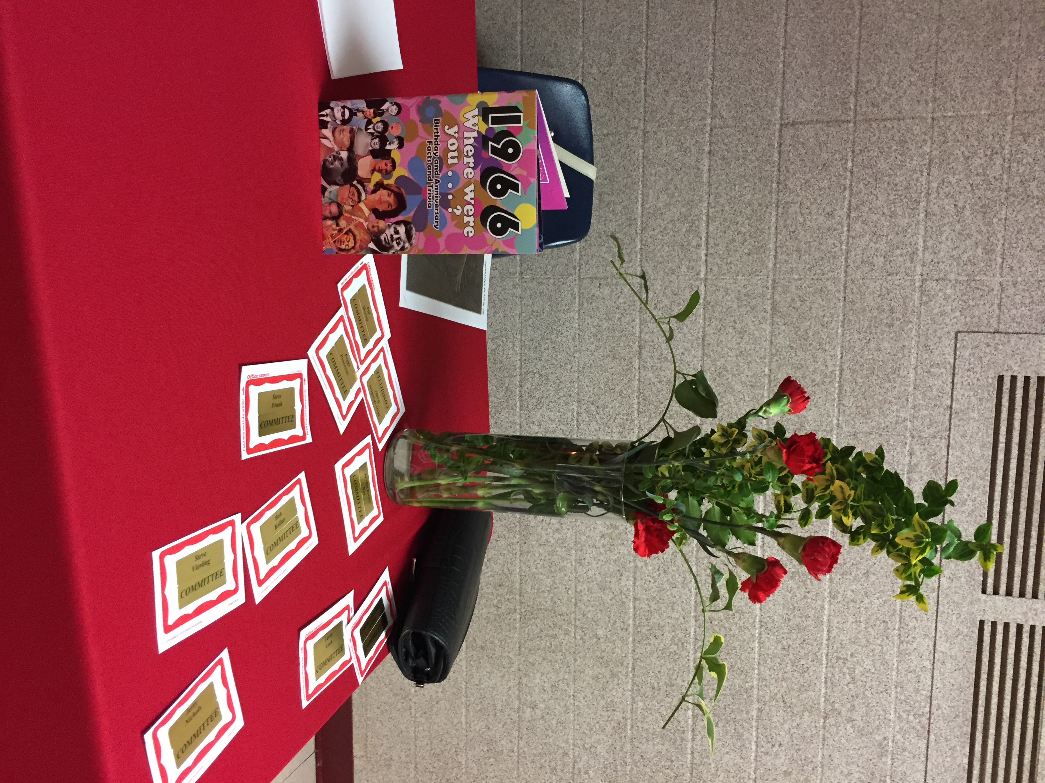
- Nametags
  - It is a great idea to have nametags as the reunion as people will have changed.
  - If you would like to add yearbook photos to the nametags it is up to the committee to scan, copy and arrange pictures on the nametags.
- Creating a Hashtag
  - If your class is social media savvy a fun way to interact is creating a reunion hashtag.
- Simple Friday Welcome Event
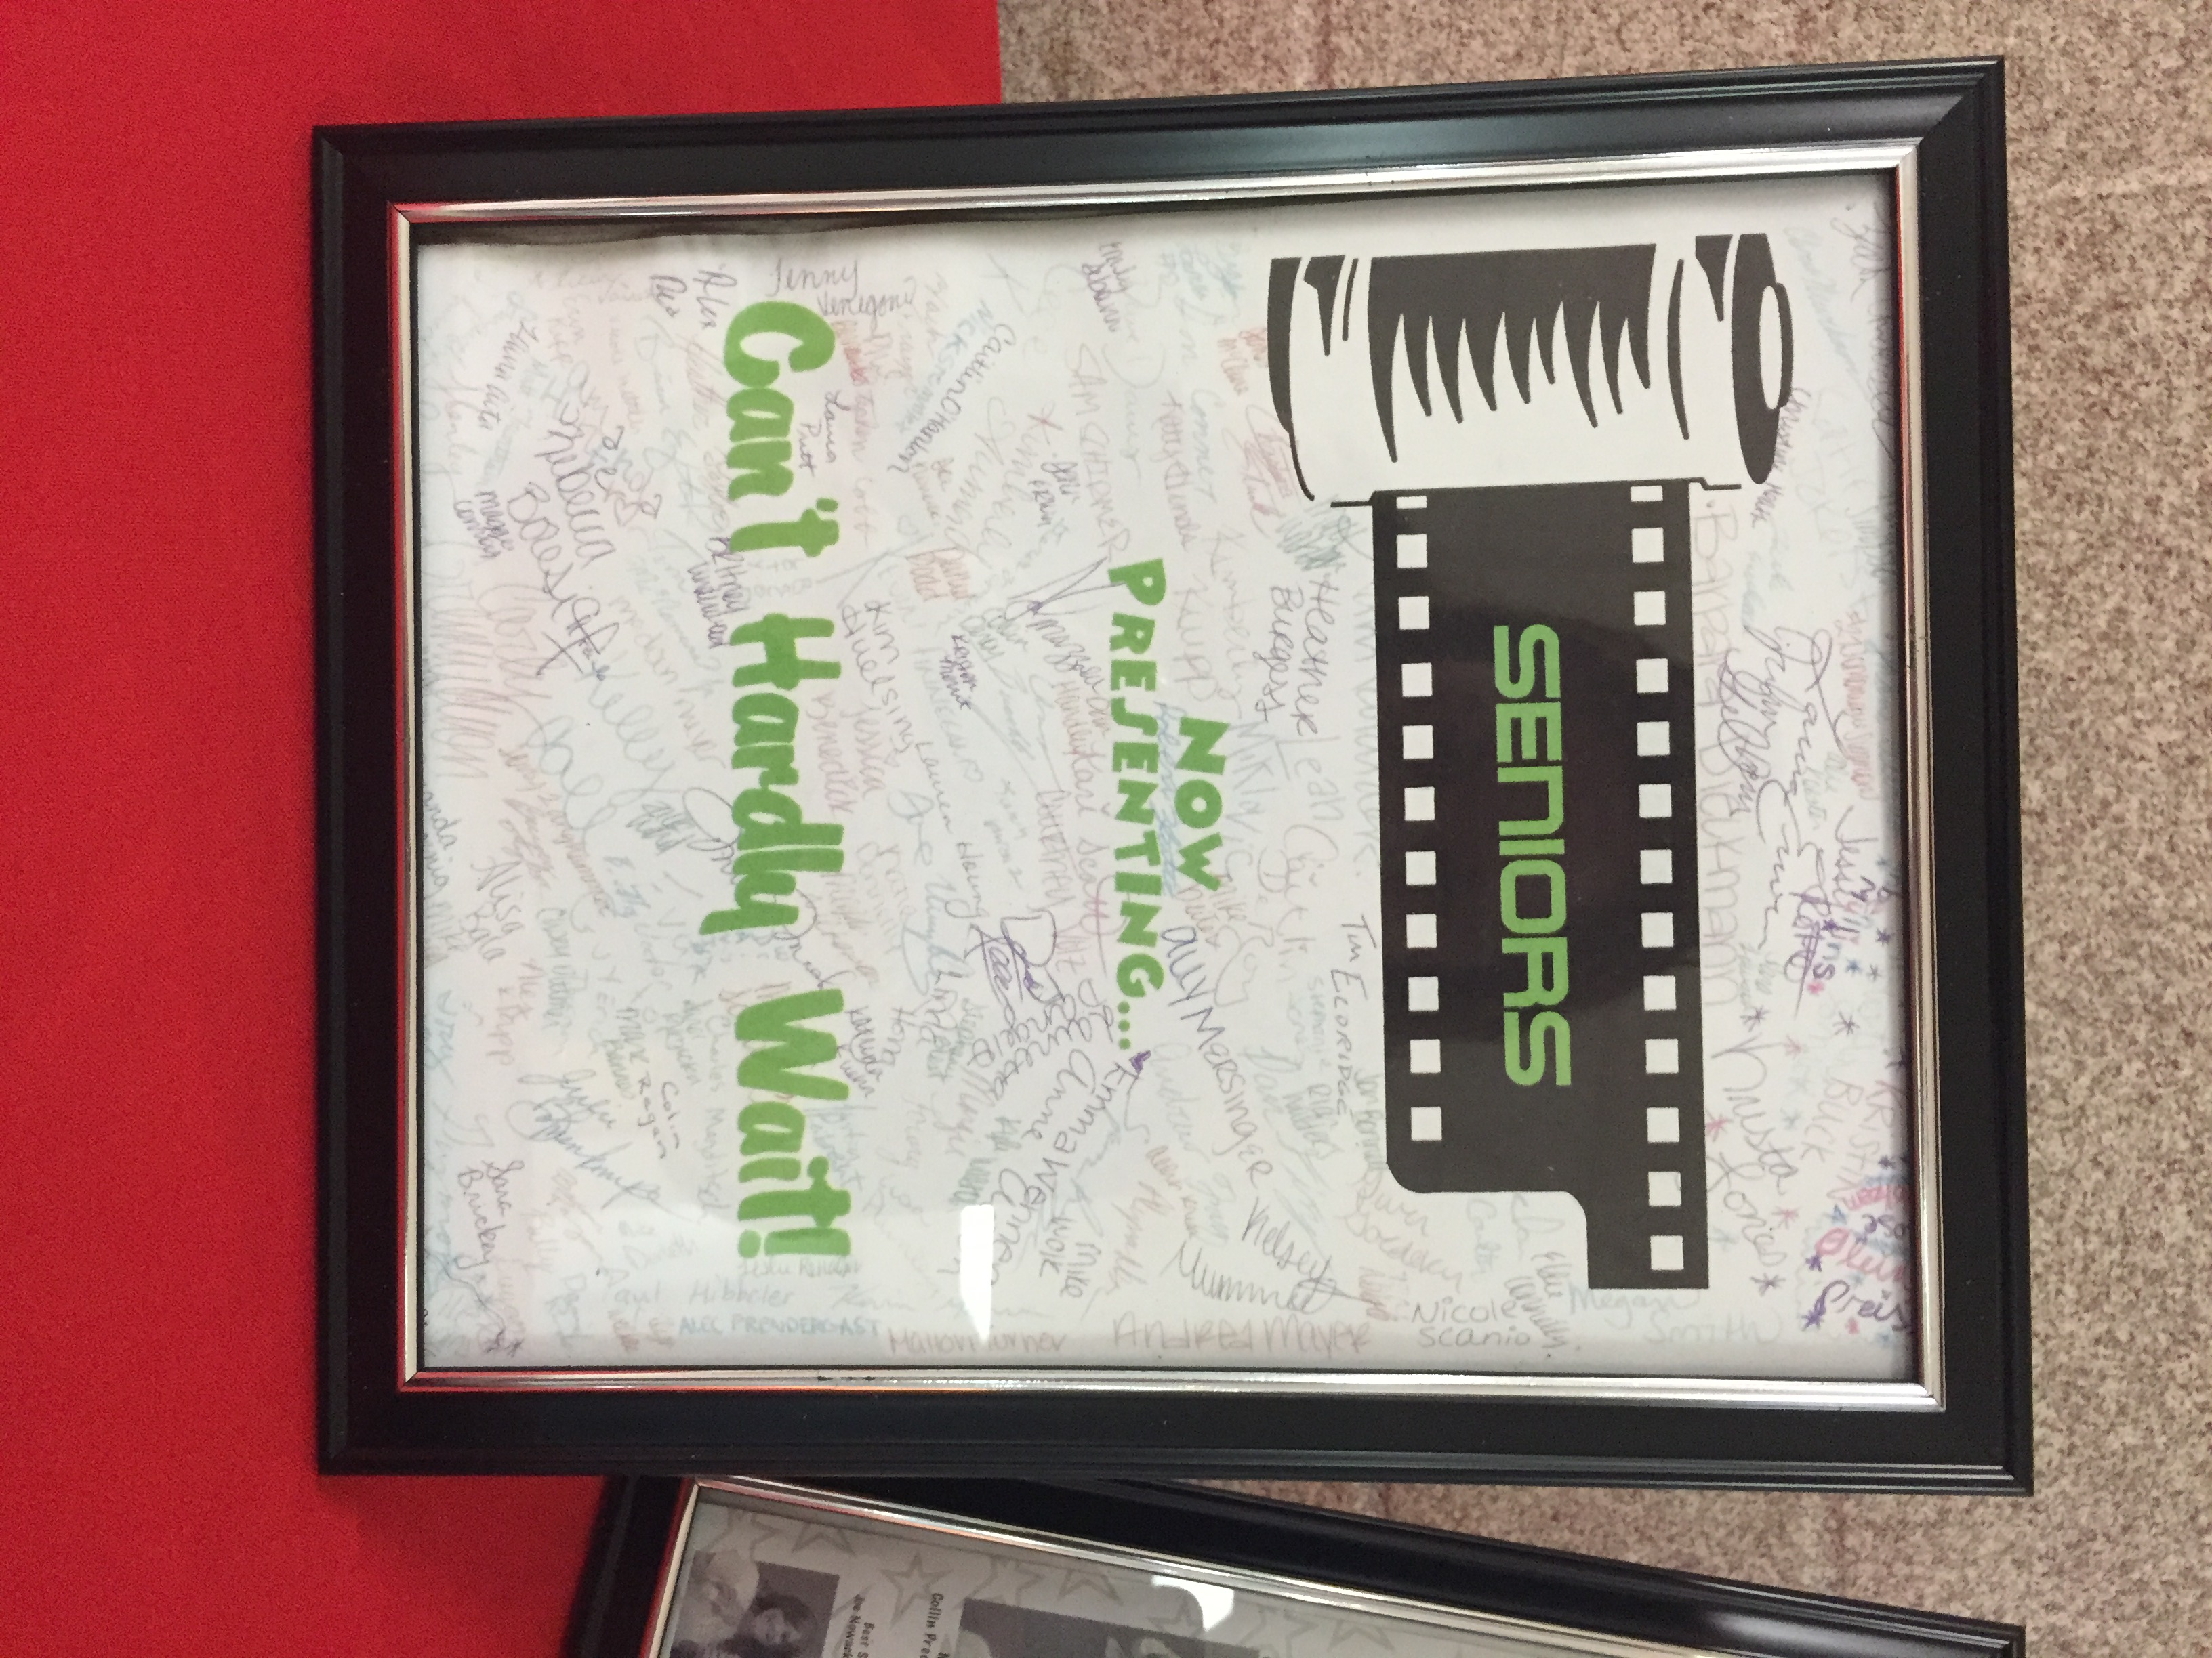
  - Some reunions are now hosting weekend activities with the reunion on Saturday and on Friday doing a very lowkey event such as a bar night, football game or something.
- School Tour
  - Don’t forget to talk up to your classmates about going on a school tour! Great way for everyone to see all the new things as well as share memories.
- Photo Groups
  - At many reunions it is fun to call out different groups for group photos. Some examples include:
    - Grade School Groups
    - Sports Groups
    - Married Classmates
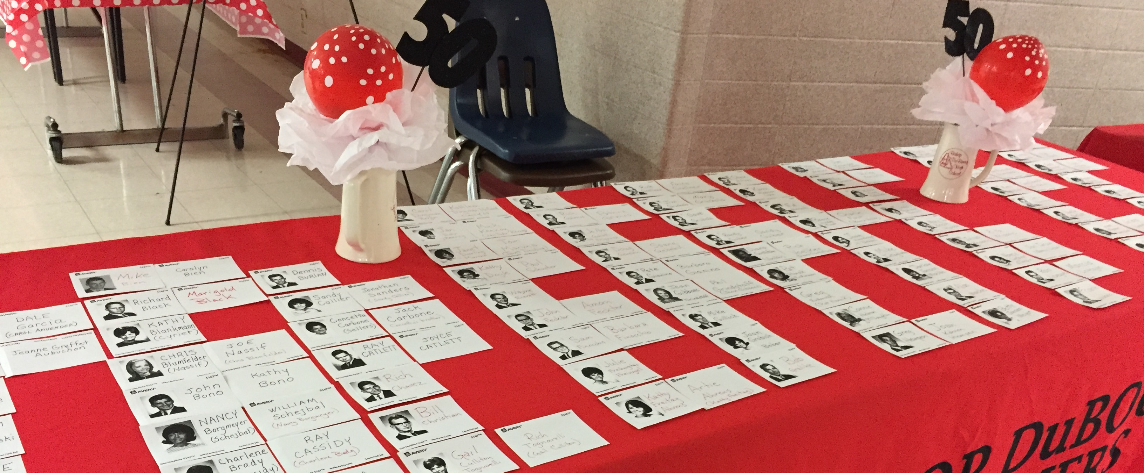
Creating a Memory

There are many ways to make your reunion memorable. Some ideas include:

- Alumni Directory/Memory Book - use info collected through surveys (with permission)
- Memory Book – filled with pictures and quotes
- Video Slideshow – created with old and new photos
- Photos for Website/Facebook – Place disposable cameras on tables
- Cavalier Paper – Place old copies of the Cavalier on the tables
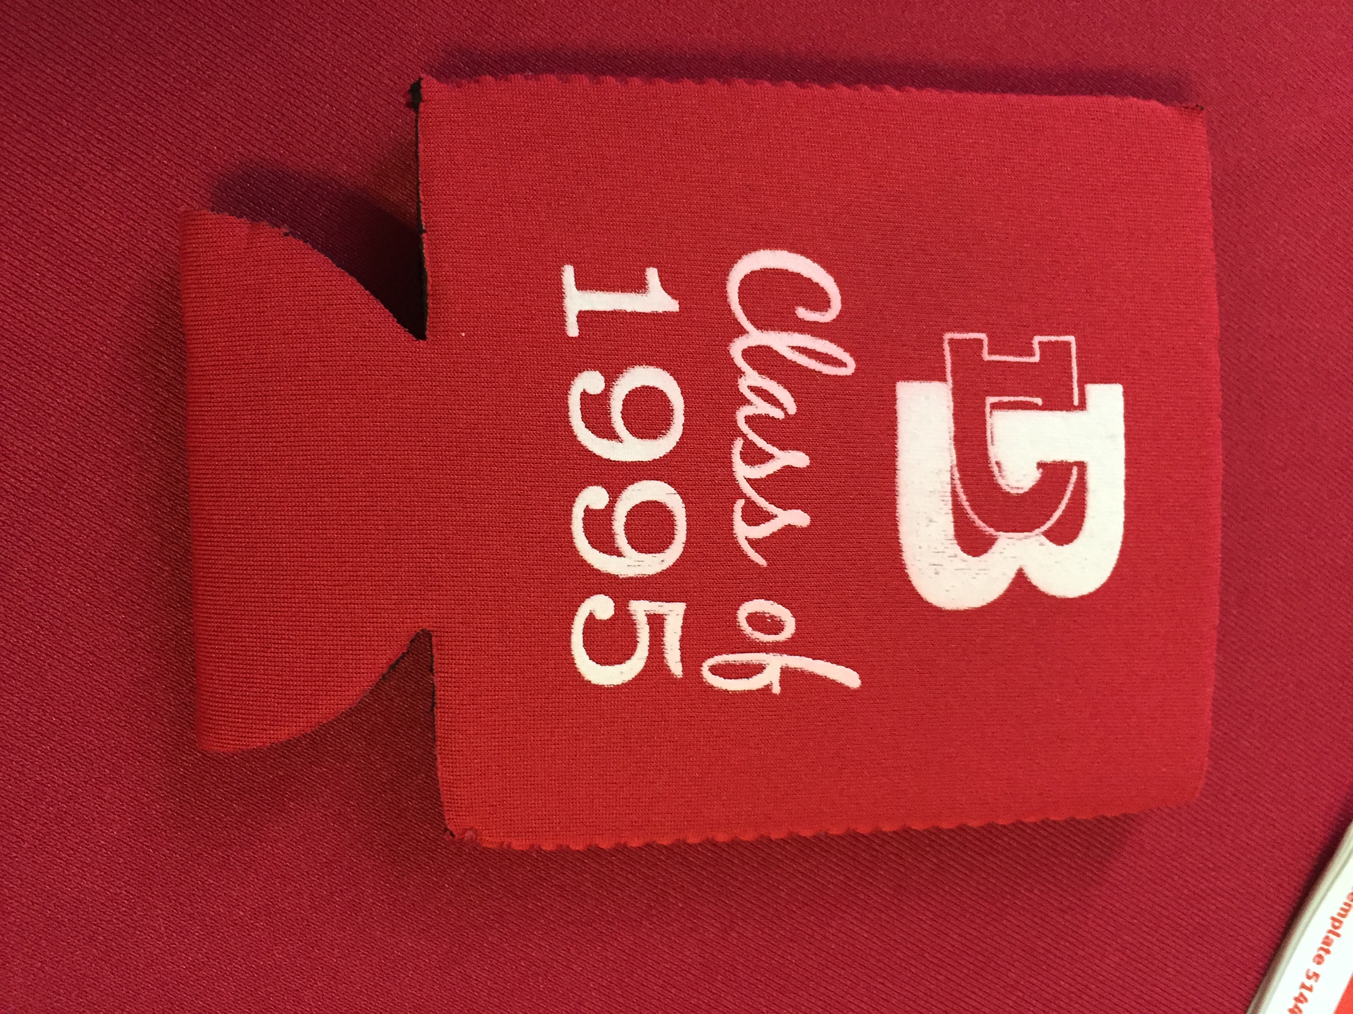
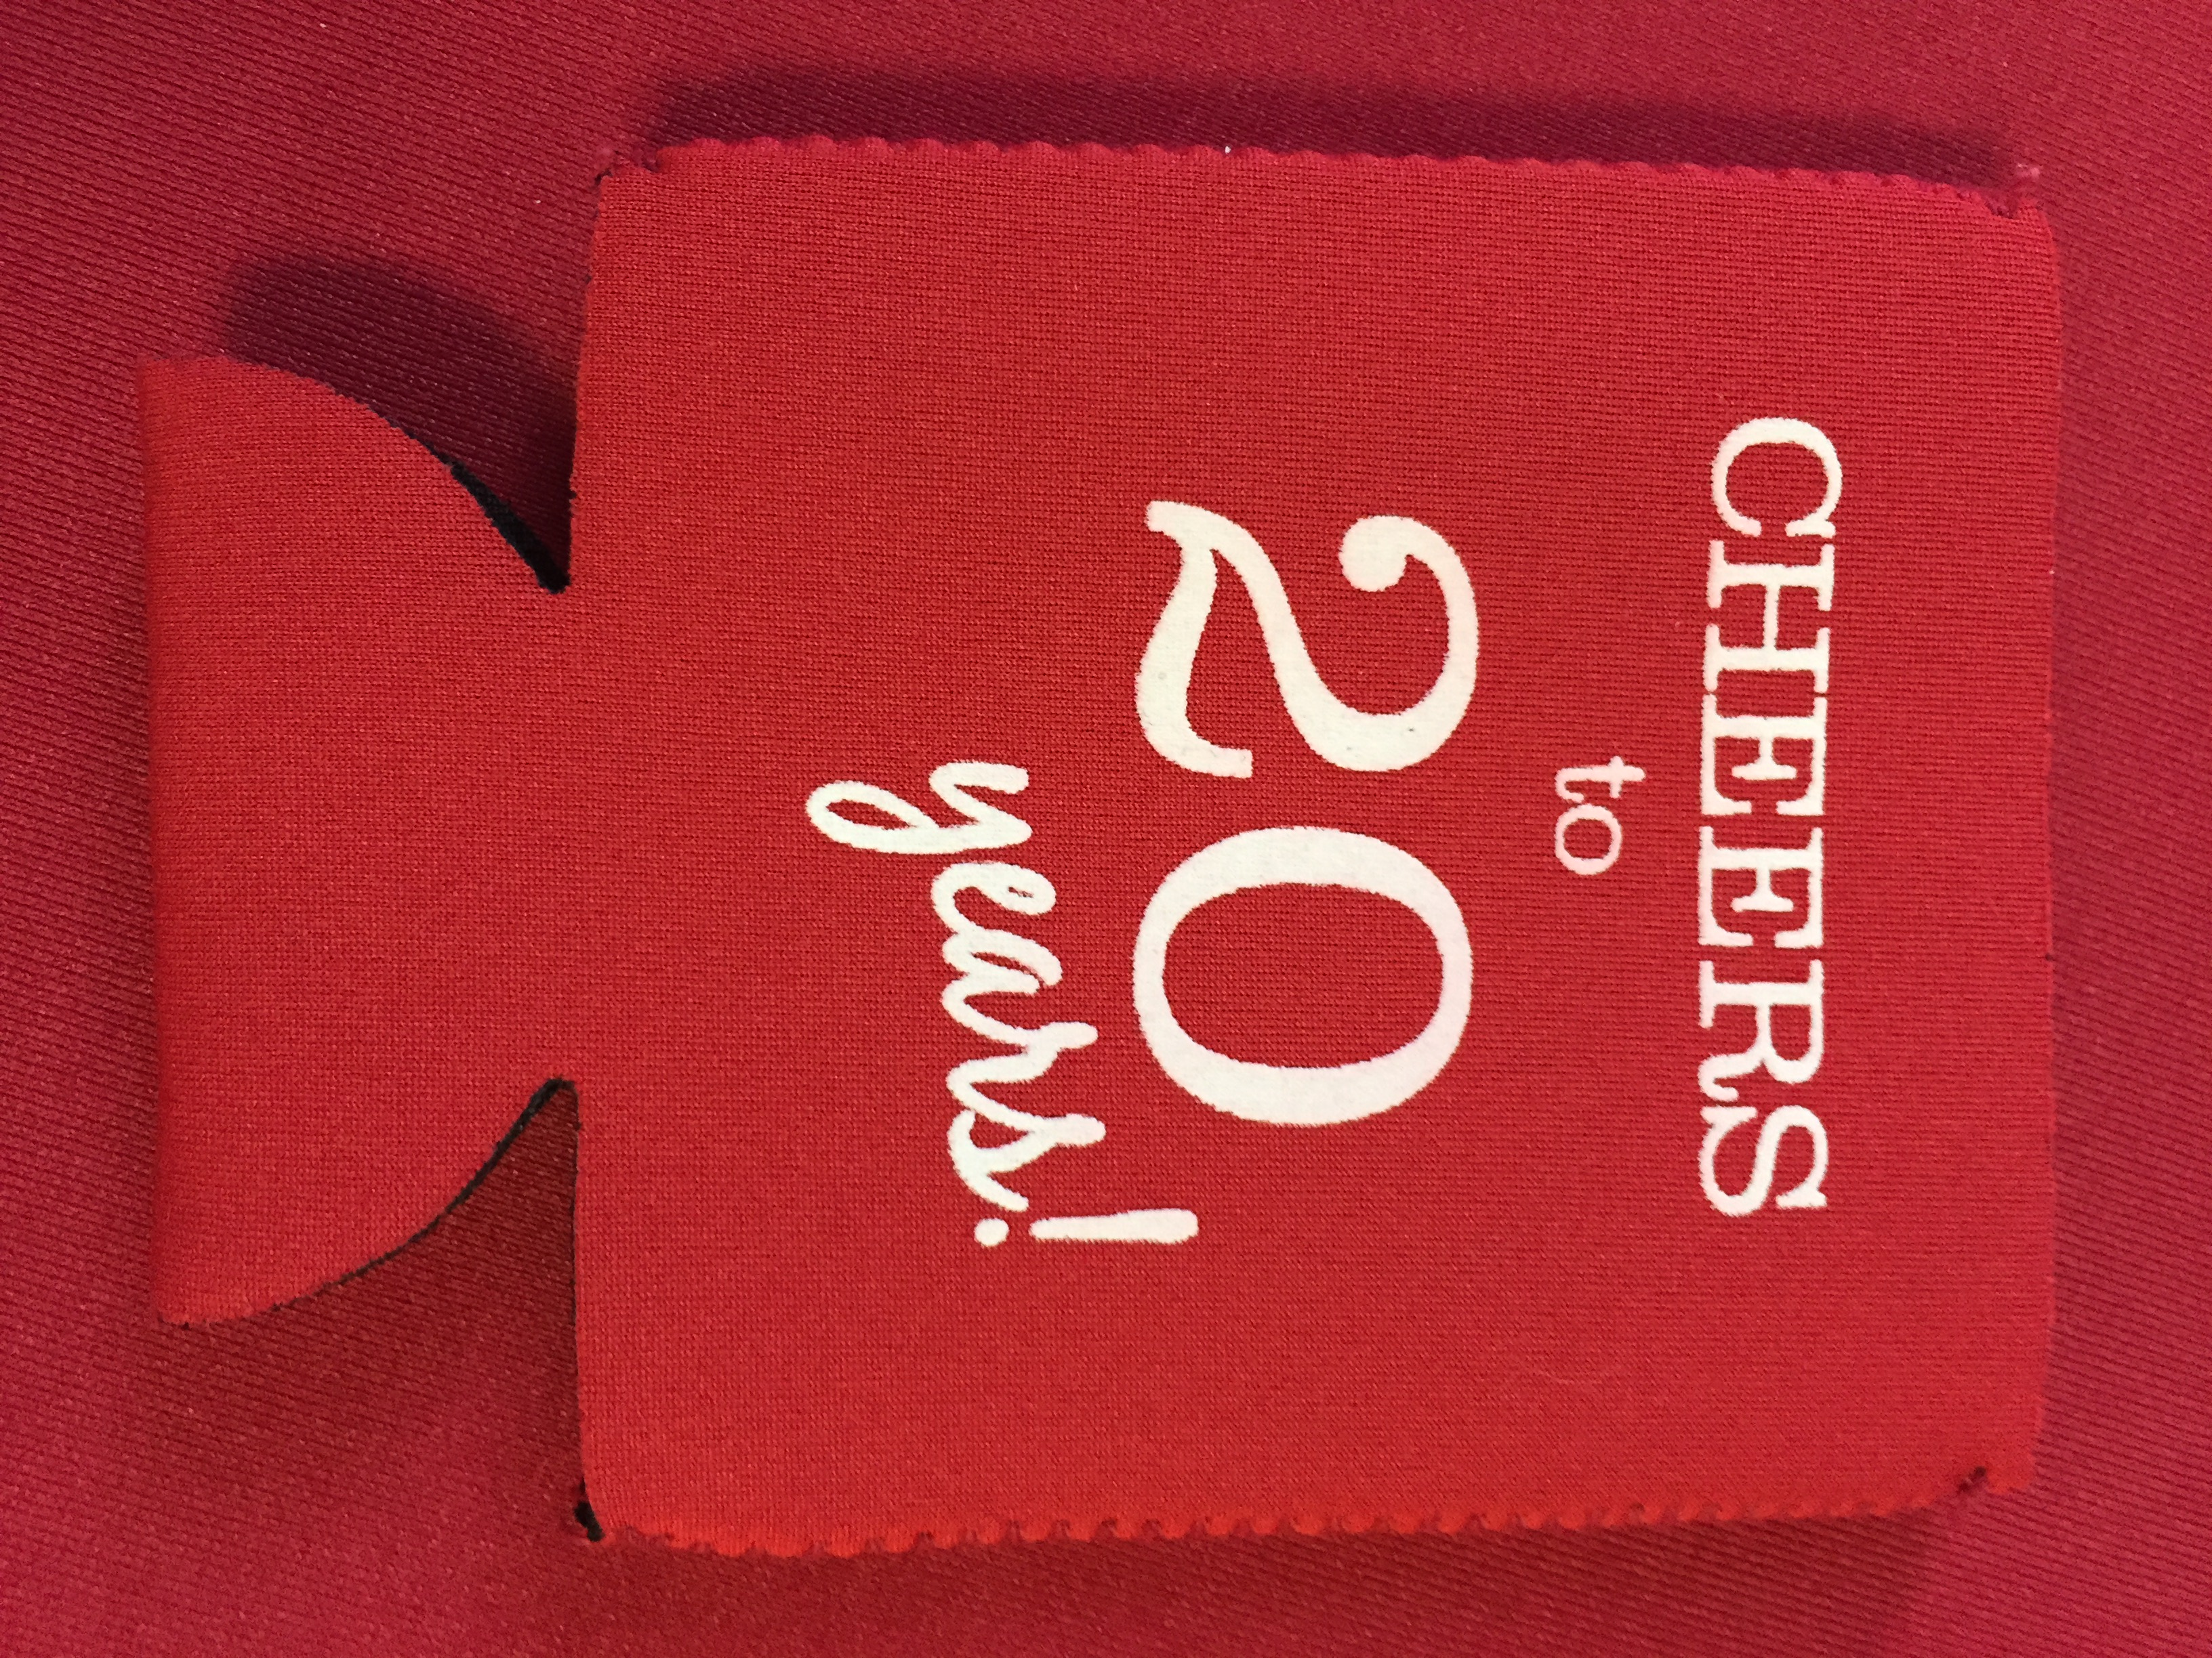
Gift Ideas –
- T-Shirts
- Hats
- Mugs
- Key Rings
- Glasses
- Group Photo
- Coozies

You may want to include an event at your reunion such as an Awards Ceremony (most famous, longest traveled, least hair, etc), Slide Show (current and past photos), Songs or Cheers (have DJ play songs that were popular, or have cheerleaders do the fight song)

Memorabilia Table

Yearbooks
Prom Glasses and Homecoming items
Letters from classmates who could not attend
Popular sayings or slogans
Political campaign buttons
Hall Passes
Tickets and posters from school plays
Old Homework
Snapshots
List of who was involved in what clubs
List of those dearly departed from your class
Group pictures from high school
Pictures from the last reunion
Materials for a time capsule

Memory Mementos

Have school/reunion trivia printed on napkins, handouts, or posters that alumni can read.
Create nametags with high school pictures on them, along with the person’s name.
Look at history trivia, such as at this time, gas cost ___ and the oscar for best movie was ___.

Things to consider are: Cost of these items and how it will affect ticket prices
Will the Venders send a sample?
How far in advance do you need to order?
PROOFREAD!
How much time does your committee have to devote to an extra project?

Decorations

Consider what type of decorations you would like to have at your event. DB will provide each reunion with a limited number of DB balloons. DB will also provide a limited number of posters to each reunion group. If you would like something blown up into a poster, DB must receive it the week before the reunion in order to have time to print them.

Please remember that what you bring into DB, you must also take out when the reunion is over.

Also consider prices when looking at decorations and accommodate for those in your ticket price.

Remember Those Who Have Passed

As we remember the past, we also remember those that we have lost. The following are some ideas:

- A Poster of Every Classmate who Has Passed
- A Picture of Each Classmate, with a Candle or Candles
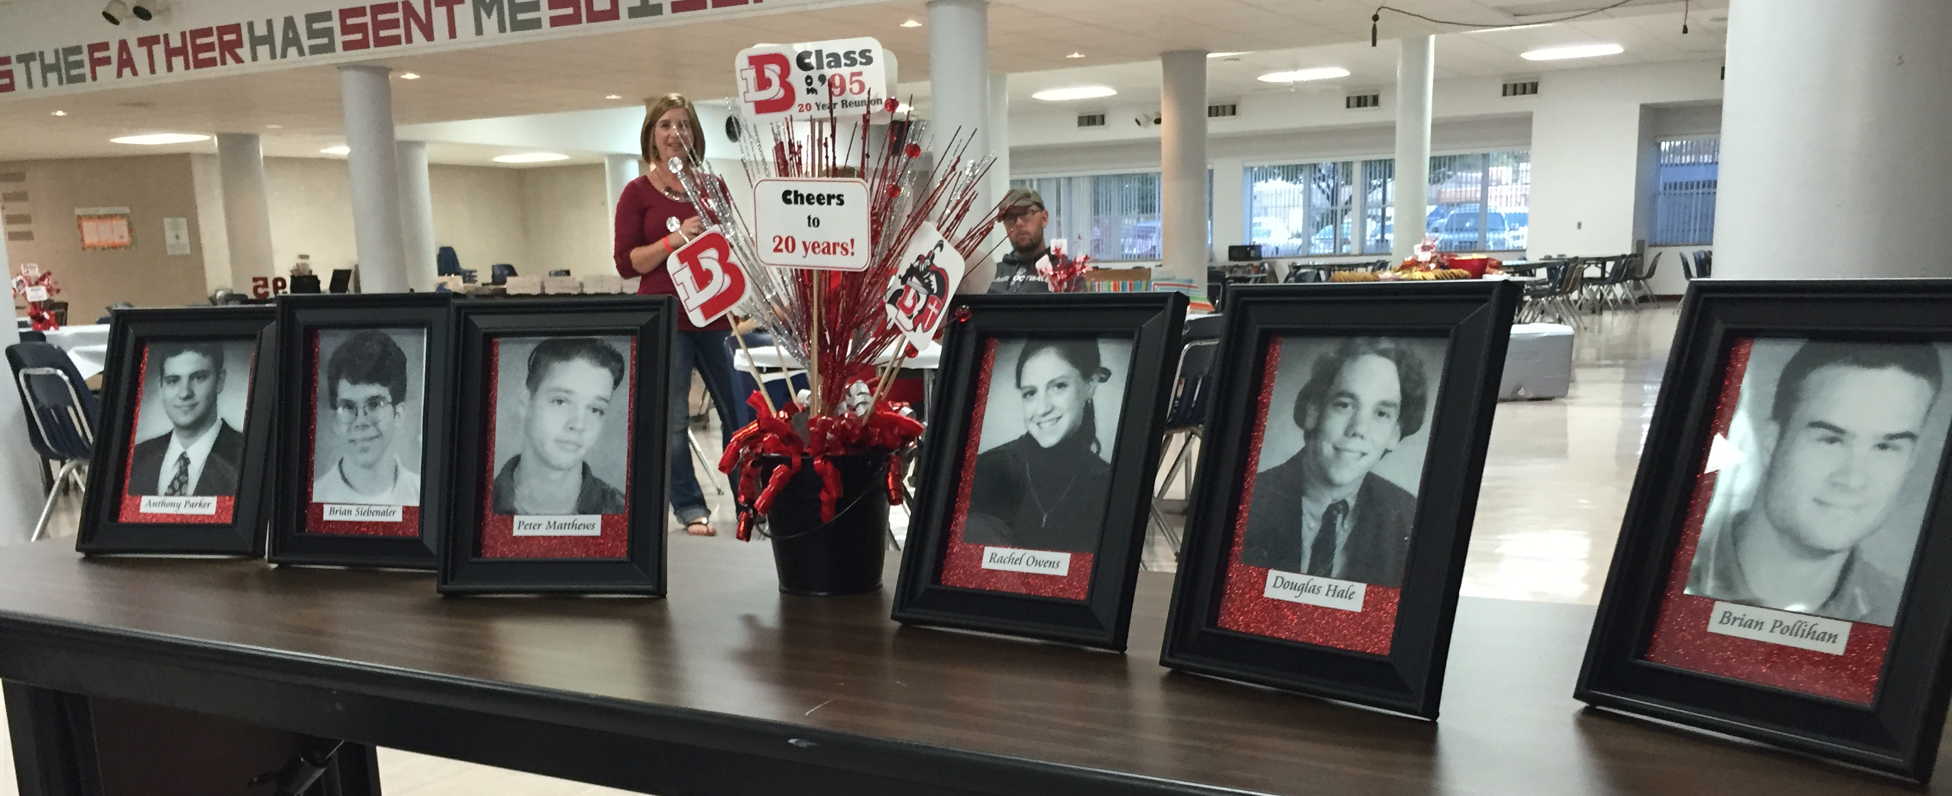
- Read Names at Mass
- Release Doves for Passed Classmates

Creating a DVD

The DBC-Live Crew at DB will put together a
DVD for your reunion to help you relive old
memories. If you would like the class to do this,
you must inform the school at least 2 months prior. The Class will scan photos from yearbooks that your committee selects and create a video slideshow for your event. If you have photos to add, you must give those to the class at least one month before the event.

After the reunion, pictures can be added to the DVD from the event.

The class will then offer to sell the DVDs to all classmates at the reunion. Forms will be available at the reunion for guests to fill out and purchase DVDs. They will then be mailed to the guests.

** Please Remember That These Are STUDENT PROJECTS. If you would like a professional project done for the reunion, please consider paying a company for a DVD.

** If you would like to use these as your reunion giveaway you must tell the office ahead of time to ensure that there is enough DVDs and envelopes.
Recognition Award Ideas

Award Gift

Most Famous Sunglasses

Longest Married Man/Woman Champagne Glasses, Ball and Chain

Newest Bride/Groom Cookbook, Apron

Married Most Often Bag of Rice

Most Eligible Bachelorette/Bachelor PlayGirl, PlayBoy, Mini Sewing Kit, Blackbook

Mom/Dad with Most Children Ear Plugs, Bottle of Aspirin, Planning Calendar

Most Pregnant Baby Gift

Most Changed / Least Changed Nametag / Hand Mirror

Man Who Lost Most Hair Hairbrush

Best Kept Figure Hourglass

Most Recent Mother/Father Ear Plugs, Diapers

Award for Twins, Triplets Cheaper By The Dozen Book

Man/Woman with Most Grandkids Brag Book

Newest Grandparent Mini-Rocker

First to Retire Toy Watch

Person Who Traveled the Farthest US Map

Most Unusual Occupation Desk Item

Lived In Most Cities/States US City Map

Lives Closest To School World Map

Most Outrageous Adventure Dramamine

Most Successful Money Clip
Decorations/Memory Gift Worksheet

Table Centerpieces:

Tableclothes:

Balloons:

Memory Table:

Remember Past Classmates:

Registration Table:

Nametags:

Memory Gifts:

Cake:

Decorations:

